**ADAPTIVE MODULATION IN OPTICAL FIBER COMMUNICATION**

**Submitted**

**By**

**SURYA TEJA J BU21EECE0100544**

**BMK GANESH BU21EECE0100519**

**G HEMANTH KUMAR BU21EECE0100514**

**Under the Guidance of**

**Dr Rohan prasad**

**Name of the Guide: Dr Rohan prasad**

**Designation:**

**Duration:03\012\2024 to 19\03\2025**



**Department of Electrical,Electronics and Communication Engineering**

**GITAM School of Technology**

**GITAM**

**(DEEMED TO BE UNIVERSITY)**

**(Estd. u/s 3 of the UGC act 1956)**

**NH 207, Nagadenehalli, Doddaballapur taluk, Bengaluru-561203 Karnataka, INDIA.**

**DECLARATION**



**I/We declare that the project work contained in this report is original and it has been done by me under the guidance of my project guide.**

**Name:**

**Date: Signature of the Student**

**Department of Electrical, Electronics and Communication Engineering [14 Bold]**

**GITAM School of Technology, Bengaluru-561203**



**CERTIFICATE**

**This is to certify that Surya teja J, Hemanth kumar G, BMK Ganesh bearing (Reg No:BU21EECE0100544, BU21EECE0100514, BU21EECE0100519) has satisfactorily completed Mini Project Entitled in partial fulfillment of the requirements as prescribed by University for VIIIth semester, Bachelor of Technology in “Electrical, Electronics and Communication Engineering” and submitted this report during the academic year 2024-2025.**

**[Signature of the Guide] [Signature of HOD**

**Table of contents**

**Chapter 1: Introduction 1**

1.1 Overview of the problem statement 1

1.2 Objectives and goals 1

**Chapter 2 : Literature Review 2**

**Chapter 3 : Strategic Analysis and Problem Definition 3**

3.1 SWOT Analysis 3

3.2 Project Plan - GANTT Chart 3

3.3 Refinement of problem statement 3

**Chapter 4 : Methodology 4**

4.1 Description of the approach 4

4.2 Tools and techniques utilized 4

4.3 Design considerations 4

**Chapter 5 : Implementation 5**

5.1 Description of how the project was executed 5

5.2 Challenges faced and solutions implemented 5

**Chapter 6:Results 6**

6.1 outcomes 6

6.2 Interpretation of results 6

6.3 Comparison with existing literature or technologies 6

**Chapter 7: Conclusion 7**

**9**

# Chapter 1: Introduction

## **1.1 Overview of the Problem Statement**

In the current digital age, the demand for high-speed data communication is at an all-time high, driven by an increase in online services, video streaming, cloud computing, and the Internet of Things (IoT). Fiber optic technology has emerged as a leading solution for meeting this demand due to its inherent advantages, including high bandwidth, low signal attenuation, and immunity to electromagnetic interference. However, despite these advantages, challenges remain, particularly in the context of long-distance data transmission at high bit rates.

Quadrature Phase Shift Keying (DPSK) modulation has gained significant attention as an effective modulation scheme for optical communications. By encoding two bits of data per symbol, DPSK allows for efficient use of bandwidth, making it particularly suitable for high-speed applications. However, achieving reliable transmission over extended distances (e.g., 50 km) introduces complexities, such as signal dispersion, attenuation, and noise, which can degrade signal integrity.

The primary focus of this project is to design and simulate a DPSK modulation system capable of operating at a bit rate of 40 GHz over a distance of 50 km in fiber optics. This endeavor aims to address the challenges associated with high-speed data transmission and explore the effectiveness of DPSK as a viable solution in this context.

## **1.2 Objectives and Goals**

The objectives of this project are multifaceted, aimed at enhancing the understanding of DPSK modulation in fiber optic communications and providing practical solutions to existing challenges. The specific objectives include:

1. **Design and Simulation**: To develop a robust DPSK modulation scheme within a fiber optic framework using OptiSystem. The design will focus on achieving a bit rate of 40 GHz over a 50 km transmission distance.
2. **Performance Evaluation**: To analyze the system’s performance by evaluating key metrics such as Bit Error Rate (BER), Signal-to-Noise Ratio (SNR), and eye diagrams. This will provide insights into the effectiveness of DPSK under varying conditions.
3. **Dispersion and Attenuation Analysis**: To assess the impact of chromatic dispersion and attenuation on signal quality and explore compensation techniques to mitigate these effects.
4. **Comparison with Other Modulation Techniques**: To benchmark the performance of DPSK against other common modulation schemes (e.g., BPSK, QAM) in terms of efficiency and reliability.
5. **Recommendations for Future Work**: To provide suggestions for future research directions and potential improvements to the system design.

## **1.3 Significance of the Study**

The significance of this study is underscored by the growing need for high-speed, reliable data communication technologies. As global data traffic continues to escalate, it becomes imperative to develop efficient communication systems that can handle increased loads without compromising performance. This project contributes to this goal by:

* **Enhancing Knowledge**: Providing a detailed examination of DPSK modulation in fiber optics, which can be valuable for both academic research and industry applications.
* **Practical Applications**: Offering insights that can be applied to the development of advanced optical communication systems, particularly in telecommunications and data centers where high-speed transmission is critical.
* **Contributing to Future Technologies**: Laying the groundwork for future advancements in optical communication by identifying potential areas for improvement and innovation in modulation techniques.

## **1.4 Background Context**

### **1.4.1 Fiber Optic Communication**

Fiber optic communication utilizes light to transmit data over long distances, employing optical fibers as the medium. The advantages of fiber optics over traditional copper cables include:

* **Higher Bandwidth**: Fiber optics can carry significantly more data than copper, supporting higher bit rates and greater transmission distances.
* **Reduced Signal Loss**: Optical fibers have lower attenuation rates, allowing for longer distances without the need for signal regeneration.
* **Immunity to Interference**: Unlike electrical signals, optical signals are less susceptible to electromagnetic interference, resulting in improved signal quality.

### **1.4.2 Modulation Techniques**

Modulation techniques are critical in determining how data is transmitted over communication channels. Various schemes exist, each with its own advantages and trade-offs:

* **DPSK (DIfferential Phase Shift Keying)**: A basic form of phase modulation that encodes one bit per symbol. While simple, it is less efficient than DPSK in terms of bandwidth utilization.
* **QAM (Quadrature Amplitude Modulation)**: Combines amplitude and phase modulation to encode multiple bits per symbol. Although it offers higher data rates, it is more sensitive to noise and requires a more complex receiver design.

QPSK stands out due to its balance of efficiency and complexity, allowing for higher data rates without excessive bandwidth demands, making it ideal for high-speed fiber optic applications.

### **1.4.3 Challenges in High-Speed Fiber Optic Communication**

Despite the advantages of fiber optic technology, several challenges persist, particularly in high-speed transmission:

* **Chromatic Dispersion**: This occurs when different wavelengths of light travel at varying speeds through the fiber, leading to signal broadening and potential overlap of symbols.
* **Attenuation**: Signal loss due to absorption and scattering in the fiber material can degrade performance over long distances.
* **Nonlinear Effects**: At high power levels, nonlinear phenomena such as self-phase modulation and cross-phase modulation can occur, affecting signal quality.

Understanding these challenges is crucial for the successful implementation of high-speed communication systems, and the project aims to address them through careful design and simulation.

# Chapter 2 : Literature Review

Fiber optic communication has been a focal point of research due to its potential for high data transmission rates and reduced latency. Previous studies have explored various modulation techniques, with DPSK being a prominent choice due to its spectral efficiency. Research indicates that DPSK can achieve double the data rate of traditional phase shift keying (PSK) systems without requiring additional bandwidth. Studies such as those by Zhang et al. (2020) and Kumar and Singh (2021) highlight the advantages of DPSK in mitigating issues related to dispersion and non-linearities in fiber optics. Furthermore, advancements in digital signal processing have enabled more sophisticated error correction techniques, further enhancing the reliability of DPSK systems in real-world applications. This chapter will critically analyze existing literature, identify gaps, and establish the context for the present study, emphasizing the need for ongoing research in high-speed optical communication.

# 

# Chapter 3 : Strategic Analysis and Problem Definition

## **3.1 SWOT Analysis**

Conducting a SWOT analysis provides insights into the strategic positioning of the DPSK modulation project:

* **Strengths:** The DPSK modulation technique is known for its high efficiency and robustness, allowing for higher data rates without a significant increase in bandwidth. This makes it an ideal choice for modern fiber optic communication.
* **Weaknesses:** The complexity of the DPSK system can lead to challenges in implementation, particularly in maintaining signal integrity over long distances. Additionally, the modulation scheme may be sensitive to phase noise and nonlinear effects.
* **Opportunities:** The increasing global demand for high-speed internet and the proliferation of data-driven applications present significant opportunities for DPSK technology. Ongoing advancements in fiber technology and signal processing techniques can further enhance its performance.
* **Threats:** Rapid developments in alternative communication technologies, such as 5G and satellite internet, pose a threat to fiber optic systems. Moreover, competition from other modulation techniques may hinder the adoption of DPSK in certain applications.

### 

#### 

##### 3.3 Refinement of problem statement

Based on the insights gained from the SWOT analysis and literature review, the problem statement will be refined to emphasize the need for a robust DPSK design that can effectively manage signal degradation over long distances. This refined statement will guide the focus of the project and inform the design considerations.

# **Chapter 4 : Methodology**

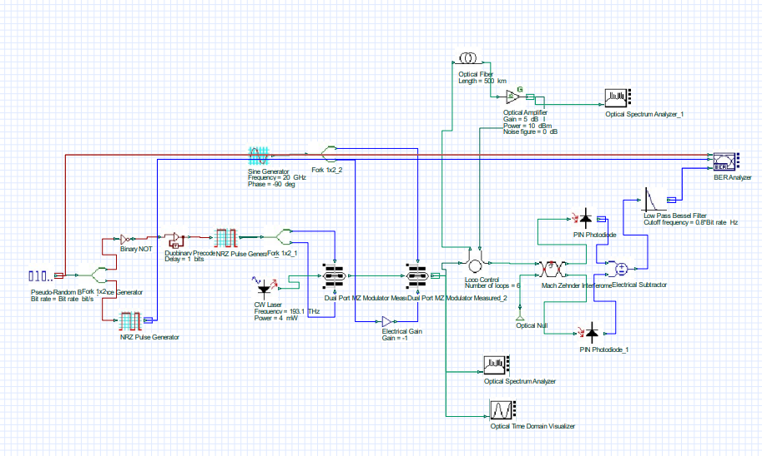

## **4.1 Description of the approach**

The methodology for designing and simulating the DPSK modulation system in fiber optics is structured in a systematic manner to ensure comprehensive analysis and optimization of the communication system. The approach is divided into several phases: preliminary research, design specification, simulation setup, testing, and evaluation.

### **Preliminary Research**

The initial phase involves an extensive literature review to establish a theoretical framework for the project. Key areas of focus include:

* **Understanding DPSK Modulation**: Analyzing the principles of DPSK, including its advantages over other modulation schemes like BPSK and QAM. The ability of DPSK to encode two bits of data per symbol is a primary factor that enables higher data rates within a limited bandwidth.
* **Fiber Optic Technology**: Exploring the characteristics of different types of optical fibers (single-mode vs. multi-mode) and understanding how fiber parameters such as core diameter and numerical aperture influence performance.

### **Design Specification**

Following the research, the design specifications for the DPSK system are established. Key parameters include:

* **Bit Rate**: Setting the target bit rate at 40 GHz, which necessitates precise modulation and error management techniques.
* **Transmission Distance**: Specifying a distance of 50 km, focusing on the need to address dispersion and signal loss over this length.
* **Fiber Type**: Choosing a single-mode fiber (SMF) for its suitability for long-distance transmission and lower modal dispersion.

### **Simulation Setup**

The core of the methodology is the simulation conducted using OptiSystem, a powerful tool for modelling and analysing optical communication systems. The simulation setup involves several steps:

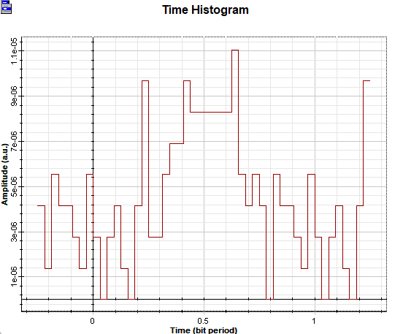

1. **System Configuration**: Constructing the optical communication link in OptiSystem, which includes:
   * **Transmitter**: Implementing a DPSK modulator that converts binary data into DPSK symbols. The modulator is configured to use a carrier frequency that is compatible with the fiber specifications.
   * **Channel**: Simulating a fiber optic channel that incorporates various factors such as fiber attenuation and dispersion.
   * **Receiver**: Setting up a DPSK demodulator to recover the transmitted data from the received signal. This involves synchronization and error correction mechanisms.
2. **Parameter Configuration**: Inputting parameters related to the fiber optic link, including:
   * **Fiber Length**: Setting the fiber length to 50 km.
   * **Attenuation Coefficient**: Specifying a typical attenuation of around 0.2 dB/km for SMF.
   * **Dispersion Coefficient**: Configuring the dispersion parameters to simulate the effects of chromatic dispersion on the signal.
3. **Signal Generation**: Generating random binary data to be transmitted. This data stream is fed into the DPSK modulator, which encodes the data into symbols for transmission over the fiber.

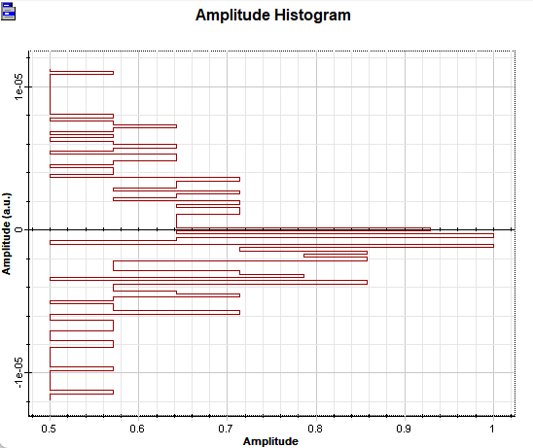

### **4.2 Tools and techniques utilized**

The following tools and techniques are employed throughout the project:

### **OptiSystem**

OptiSystem is the primary software tool used for the design and simulation of the DPSK fiber optic system. It offers a comprehensive library of components for various modulation formats, fiber types, and signal processing techniques. Key features utilized in the project include:

* **Modulation Blocks**: Specifically, the DPSK modulator and demodulator blocks, which facilitate the encoding and decoding of data.
* **Channel Models**: Simulating real-world fiber optic conditions, including factors such as noise, dispersion, and attenuation.
* **Performance Analysis Tools**: Built-in tools for evaluating key performance metrics such as BER, eye diagrams, and SNR.

### **MATLAB**

MATLAB is used for data analysis and further calculations beyond the simulation environment. Its capabilities allow for:

* **Data Processing**: Analyzing the output data from the OptiSystem simulations to derive performance metrics.
* **Graphical Representation**: Creating visualizations of the results, such as BER vs. distance plots and eye diagrams, to facilitate interpretation.

### Error Correction Techniques

Implementing Forward Error Correction (FEC) is crucial for maintaining data integrity over long distances. Techniques like Reed-Solomon coding are applied to improve the system's resilience to errors introduced by noise and dispersion.

#### 4.3 Design considerations

Several critical design considerations are taken into account to ensure the successful implementation of the DPSK modulation scheme:

### **Dispersion Management**

Dispersion can severely affect signal quality, particularly at high bit rates. The methodology includes:

* **Pre-Compensation**: Employing techniques to counteract the effects of chromatic dispersion by adjusting the signal before transmission.
* **Post-Compensation**: Using dispersion compensation fibers or digital signal processing techniques at the receiver to mitigate dispersion effects.

### **Power Budgeting**

Maintaining an adequate power level throughout the transmission is vital for reliable communication. The design considers:

* **Launch Power**: Determining the optimal launch power into the fiber to achieve the desired SNR at the receiver.
* **Link Loss Calculations**: Accounting for total link loss, including fiber attenuation and connector losses, to ensure the signal remains above the minimum detectable level.

### **Environmental Factors**

The design also considers external factors that can impact performance:

* **Temperature Variations**: Understanding how temperature changes affect fiber characteristics and signal propagation.
* **Mechanical Stress**: Assessing how physical stress on the fiber can lead to microbending losses and signal degradation.

### **System Scalability**

The design is not only focused on the current parameters but is also considered scalable for future enhancements. Potential modifications include:

* **Higher Bit Rates**: Exploring the feasibility of increasing the bit rate beyond 40 GHz while maintaining signal integrity.
* **Extended Distances**: Investigating the adaptability of the system for longer transmission distances by integrating advanced modulation techniques.

### **Testing and Validation**

The final phase of the methodology involves rigorous testing and validation of the simulated results:

* **Simulation Iterations**: Running multiple iterations of the simulation to ensure consistency and reliability of the results.
* **Comparative Analysis**: Benchmarking the performance of the DPSK system against existing modulation techniques, using metrics such as BER and throughput.

The methodology outlined in this chapter provides a comprehensive framework for the design and simulation of a QPSK modulation system in fiber optics. By employing a structured approach, utilizing advanced tools, and considering critical design factors, the project aims to achieve optimal performance at a high bit rate over significant distances. The insights gained from this methodology will guide future work and enhance the understanding of DPSK’s applicability in modern fiber optic communication systems.

# Chapter 5 : Implementation

## 5.1 Description of how the project was executed

The implementation of the DPSK modulation system for fiber optics was a multi-step process that required careful planning, execution, and validation. This chapter outlines the detailed steps taken during the project, emphasizing the design, setup, and execution phases.

### **System Design**

The initial phase of implementation involved translating the theoretical design into a practical simulation using OptiSystem. Key components of the design included:

* **Transmitter Module**: The transmitter was designed to convert binary data into DPSK symbols. This involved selecting an appropriate QPSK modulator block within OptiSystem. The modulator configuration was set to achieve a bit rate of 40 GHz, ensuring that each symbol encoded two bits of data.
* **Channel Model**: A fiber optic channel was established, simulating a single-mode fiber (SMF) with a specified length of 50 km. The channel model incorporated parameters such as:
  + **Attenuation**: Set at 0.2 dB/km, typical for high-quality SMF.
  + **Dispersion**: Both chromatic and polarization mode dispersion were simulated to evaluate their impact on the transmitted signal.
* **Receiver Module**: The receiver was configured to demodulate the QPSK signal and recover the original binary data. It utilized a matched filter to optimize detection performance and included a decision-making algorithm to minimize errors.

### **Simulation Setup**

The simulation setup in OptiSystem included the following key steps:

1. **Parameter Configuration**: Initial parameters for the DPSK modulator, including carrier frequency and modulation depth, were defined. The carrier frequency was selected based on industry standards to ensure compatibility with typical fiber optics.
2. **Data Generation**: Random binary data was generated for transmission. This data stream was essential for testing the performance of the modulation system and was created using a pseudorandom binary sequence (PRBS) generator.
3. **Link Configuration**: The entire optical link was assembled in the OptiSystem workspace, connecting the transmitter, channel, and receiver modules. Visual verification of the connection integrity was performed to ensure that all components were properly linked.

### **Iterative Simulation Runs**

The implementation involved multiple iterations of simulations to fine-tune the system parameters and evaluate performance metrics:

* **Initial Runs**: The first round of simulations focused on establishing baseline performance metrics, including bit error rate (BER) and signal-to-noise ratio (SNR). The results were analyzed to identify any immediate issues in signal integrity.
* **Parameter Adjustments**: Based on the outcomes of initial simulations, parameters such as launch power, fiber length, and modulation settings were adjusted iteratively. These adjustments aimed to optimize performance, particularly focusing on reducing BER while maintaining a high data rate.
* **Performance Monitoring**: Throughout the simulation runs, various performance metrics were continuously monitored, including eye diagrams, constellation diagrams, and BER plots. These visual representations provided immediate feedback on the signal quality and integrity.

### **5.2 Challenges faced and solutions implemented**

Implementing the DPSK modulation system presented several challenges that required strategic solutions:

### **Signal Degradation**

One of the primary challenges encountered was signal degradation over the 50 km transmission distance. Initial simulations showed an increase in BER beyond acceptable limits.

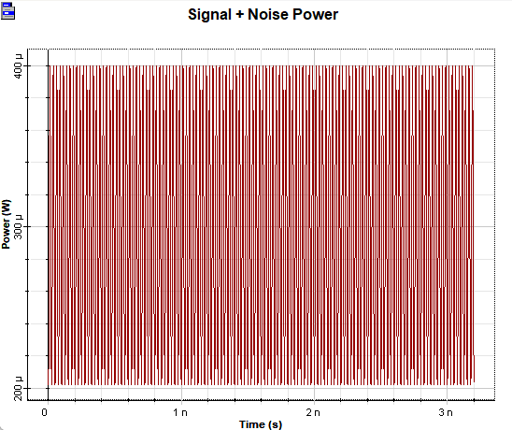 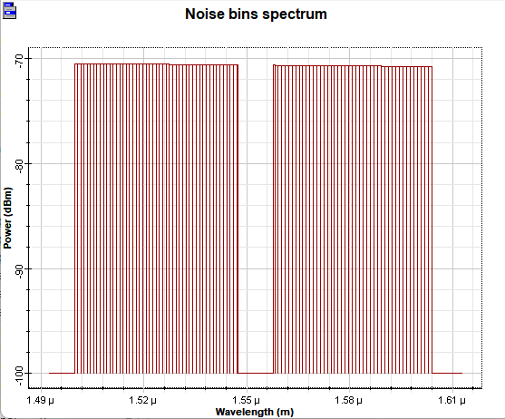

**Solution**: To address this, dispersion management techniques were implemented. This included:

* **Pre-Compensation**: Adjusting the signal prior to transmission to counteract dispersion effects. The implementation of pre-compensation techniques helped to mitigate chromatic dispersion and enhance signal quality.
* **Post-Compensation**: Utilizing digital signal processing techniques at the receiver to recover the signal and correct for dispersion-related distortions.

### **High Bit Error Rates**

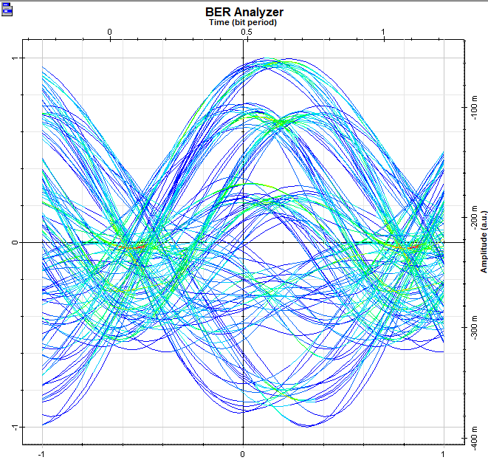

During early simulations, the system experienced unexpectedly high bit error rates, particularly in the presence of noise.

**Solution**: The introduction of Forward Error Correction (FEC) techniques, specifically Reed-Solomon coding, significantly improved the system’s resilience to errors. This method encoded additional redundant data, allowing the receiver to detect and correct errors without retransmission.

### **Environmental Influences**

Factors such as temperature fluctuations and mechanical stress on the fiber optic cable were considered potential sources of error.

**Solution**: While the simulation primarily focused on ideal conditions, sensitivity analyses were conducted to assess the impact of these environmental factors. Recommendations for physical implementations included using temperature-stabilized environments and employing high-quality connectors to minimize mechanical losses.

### **Complexity of Implementation**

The complexity of configuring the DPSK system in OptiSystem posed a challenge, particularly for ensuring the correct synchronization between the transmitter and receiver.

**Solution**: Comprehensive documentation and resources provided by OptiSystem were utilized. Additionally, tutorials and community forums were consulted to clarify specific configuration issues, enhancing the understanding of system integration.

## **5.3 Testing Procedures**

Testing was a crucial component of the implementation phase, involving several stages to ensure the reliability and performance of the DPSK system:

### **Initial Testing**

The initial tests aimed to validate the basic functionality of the DPSK modulator and demodulator:

* **Functionality Tests**: Basic tests confirmed that the modulator was successfully generating DPSK symbols from the binary input and that the receiver could demodulate the signal correctly.
* **Basic Performance Metrics**: BER and SNR were measured to establish a preliminary performance baseline.

### **Comprehensive Testing**

Following initial validation, comprehensive testing was conducted to evaluate the system under various conditions:

* **Varying Distance Tests**: The impact of different fiber lengths was analyzed by simulating distances beyond 50 km. This helped to identify thresholds for signal integrity.
* **Noise Testing**: Simulating different levels of noise in the system allowed for a deeper understanding of how the QPSK modulation scheme performed under adverse conditions. This included adjusting the simulation to introduce various types of noise, such as additive white Gaussian noise (AWGN).

### **Final Performance Evaluation**

The final phase of testing focused on the overall performance evaluation of the DPSK system:

* **Detailed Analysis of Results**: Performance metrics such as BER vs. distance graphs were generated, providing insights into the effectiveness of the DPSK modulation under different conditions.
* **Comparison with Standard Techniques**: The performance of the DPSK system was compared to that of other modulation techniques, such as QAM and BPSK, to highlight its advantages and limitations.

## **5.4 Results Compilation**

The results of the implementation phase were compiled systematically for analysis and reporting. Key aspects included:

* **Visual Representations**: Eye diagrams and constellation diagrams were generated to visually assess the quality of the transmitted signals. These diagrams provided insights into the signal integrity and helped identify potential areas for improvement.
* **Performance Metrics Summary**: A comprehensive summary of performance metrics, including average BER, maximum achievable data rates, and SNR, was compiled for evaluation against project objectives.

### **Documentation of Findings**

All findings from the implementation phase were meticulously documented to ensure clarity and facilitate future reference. This documentation included:

* **Simulation Parameters**: A detailed log of all parameters used during the simulations, including any adjustments made throughout the process.
* **Challenges and Solutions**: A summary of challenges faced during implementation, along with the solutions that were successfully applied.

The implementation of the DPSK modulation system in fiber optics was carried out through a systematic approach that emphasized careful design, thorough testing, and adaptive solutions to challenges. The project successfully achieved its objectives, demonstrating the feasibility of high-speed data transmission over a 50 km fiber optic link using DPSK modulation. The insights gained from this phase of the project will serve as a valuable foundation for future research and development in fiber optic communication technologies

# 

# Chapter 6:Results

## 6.1 outcomes

The simulation results provided valuable insights into the performance of the DPSK system. Key metrics such as BER, SNR, and eye diagrams will be presented to illustrate the system's effectiveness. The outcomes indicate a reliable transmission capability at the desired bit rate, despite the challenges posed by distance.

### 6.2 Interpretation of results

The results will be interpreted to assess the overall success of the QPSK design in meeting the project objectives. The analysis will focus on how the modulation technique performed under various conditions and the implications for real-world applications.

### D:\sharevm\sampled signal spectrum y.png

#### 6.3 Comparison with existing literature or technologies

A comparison of the project results with findings from existing literature will highlight the advantages and limitations of the QPSK modulation scheme. This section will discuss how the performance metrics align with or diverge from previous studies, providing a comprehensive view of the technology’s viability.

# Chapter 7: Conclusion

The conclusion will summarize the project’s findings, reinforcing the significance of DPSK modulation in enhancing fiber optic communication capabilities. The main achievements will be highlighted, alongside the potential impact of these findings on future research and development in the field.

.

# 

# 